IKEA Wooden Rebirth

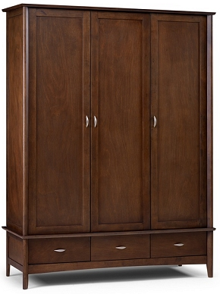

|  |
| --- |
| **DESCRIPTION** |
| IKEA dream designing has introduced an extra wide multi storage cupboard with extra griped surface. The cupboard has a nice feel with smooth surface and the brown color gives it a natural look which enables it to give a relaxing feeling. It will give your house a complete different look and a door with group of chests enable it store as well as hang goods. |

|  |  |  |
| --- | --- | --- |
| **Price** | **740$** | |
| **Dimensions** | **H** x **W** x **L** | **75in x 22in x 45in** |
| **Features** | **Three Doors and three chests are include in the design with extra long legs to improve gravity of the cupboard so that it does not fall to the ground give extra protection over children.** | |
| **Finished** | **Manchester Glow** | |
| **Available in** | **Brown and Blue** | |